**Emergency Reporting System**

**Android Application – User’s Guide**

The Elite Code smiths, Developers

Date: April 16, 2017

**CONTENTS**

**Title** **Page No.**

1. **GENERAL INFORMATION 3 - 5**
   1. System Overview 4
   2. Project References 4
   3. Authorized User Permission 4
   4. Points of Contact 4
      1. Information
      2. Help Desk
   5. Organization of the Manual 5
2. **SYSTEM SUMMARY 6 - 7**
   1. System Configuration 7
   2. User Access Levels 7
   3. Contingencies 7
3. **GETTING STARTED 8 - 15**
   1. Landing Page 9
   2. Logging On 9
   3. Account Creation and Registration 10
   4. System Menu 11
      1. Home Page 11-13
      2. File A Complaint Page 13-14
      3. Emergency Phone Numbers 15
   5. Exit System 15

**4.0 ADDITIONAL INFORMATION 16 - 18**

**1.0 GENERAL INFORMATION**

1. **GENERAL INFORMATION**

General Information section explains in general terms the system and the purpose for what application is intended.

* 1. **System Overview**

Emergency Reporting System is an Android application, restricted for Northwest Missouri State University Bearcats (Students/staff/residents). This application is developed to help bearcats in reporting emergencies such as Health, Fire, Harassments, etc., to UPD (University Police Department). UPD gets a mail containing the location of the victim when the user clicks emergency button.

* 1. **Project References**

This project is developed by studying present emergency reporting applications in Appstore. Android application development is studied from different websites like [www.vogella.com](http://www.vogella.com), [www.tutorialspoint.com/android](http://www.tutorialspoint.com/android), <http://developers.android.com>.

* 1. **Authorized Use Permission**

The application is used by two users with its different roles and functions. They are: 1. People using the application (users), 2. University Police Department Staff. Users use this application to report an emergency to police department and UPD staff use this application during information checking situations it happens in rare conditions.

* 1. **Points of Contact**

Points of contact gives information how users can contact developers if they have any problems with application usage or maintenance.

* + 1. **Information**

All necessary functions of Emergency Reporting System support services can be obtained, for queries and suggestions just send an email to the following mail addresses of the developers:

1. [moulichowdhary@gmail.com](mailto:moulichowdhary@gmail.com),
2. [makkenasrinivasrao1@gmail.com](mailto:makkenasrinivasrao1@gmail.com),
3. [m.venkatasudheer@gmail.com](mailto:m.venkatasudheer@gmail.com),
4. [chidella1994@gmail.com](mailto:chidella1994@gmail.com),
5. [kvaishureddy12@gmail.com](mailto:kvaishureddy12@gmail.com),
6. [moulichowdhary@gmail.com](mailto:moulichowdhary@gmail.com).
   * 1. **Help Desk**

Contact developers using above given email addresses.

* 1. **Organization of the manual**

The user manual consists of four sections. They are: 1. General Information, 2. System Summary, 3. Getting Started and 4. Using the system.

General Information section explains in general terms the system and the purpose for which it is intended.

System Summary section provides a general overview of the system written in a non-technical terminology. It outlines the uses of the system in supporting the activities of the users.

Getting Started section provides general idea about the system from starting point to the ending point. This acts as guideline for every user on how to utilize the system.

Using the system section provides a detailed description of the system function. This is in support to users actions.

1. **SYSTEM SUMMARY**
2. **SYSTEM SUMMARY**

System Summary section provides a general overview of the system. The summary outlines the system’s hardware and software requirements, system’s configuration, user access levels and system’s behavior in case of any contingencies.

* 1. **System Configuration**

This mobile application deals with reporting an emergency situation to university police department using gps location tracker. The design for the mobile application is composed of mapping entities to tables, user interface to interact with location of the user. The application uses back4app database in order to store the data. The application can be viewed in Appstore. It requires connection to Internet in order to launch the application and for the functionalities to work.

* 1. **User Access Levels**

Everyone can use application and the different classification of users is given below

|  |  |
| --- | --- |
| **Term** | **Definition** |
| Students | To report an emergency situation to UPD |
| UPD staff | To view the details of users in emergency conditions when there is a problem. |
| Developers | For maintaining the application and to check system functionalities. |

* 1. **Contingencies**

The application will not work if there is no internet connection and should contain google maps in the mobile.

**3.0 GETTING STARTED**

1. **GETTING STARTED**

Getting started section provides general idea about the system from initial point to the exit point. This acts as guideline for every user on how to utilize the system. First install the application from Appstore and the mobile must have internet connection for running the application.

* 1. **Landing Page**

Landing page is the first page which appears when the user opens the application and start executing. Landing page for the first time is Logging On page which consists of screen asking for email address and password which are obtained for the user when they register. Landing page when the user opens this application for second time is the Home page which means the user need not login every time when he/she uses the application.

* 1. **Logging On**

The user need to login to the application for the first time using his/her own credentials such as email address/Username in the username field and password usually in alphanumeric form (containing numbers, special symbols, uppercase and lower case letters). After entering correct details click on LogIn button. When user enters wrong details valid error messages pops up on the screen. Error messages clearly explains where and what actions are needed to rectify the mistake. LogIn page also contains Register Here button for the new users to register for this app. Forgot password button enables the user to change the password by providing the correct email address given at registration time.

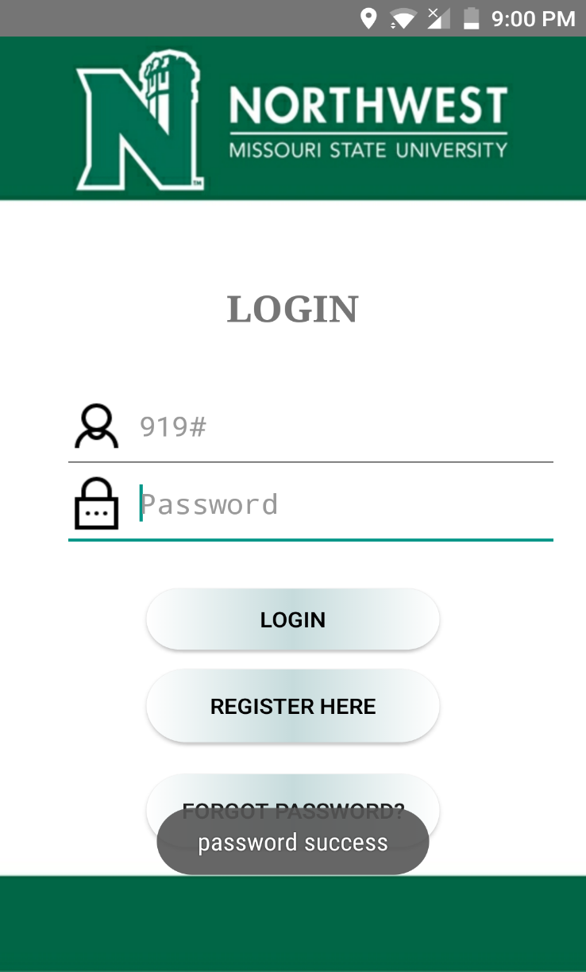

**Figure 1. Logging Page**

* 1. **Account Creation and Registration**

Click on SignUp button in Logging On page to create new account. To create a new account fill up all the fields with your personal data and set your password and username. When you enter the details and click on Register button, all the details entered by you are saved in the database which are verified when you try to logon to the application. There is a reset button to clear all the data you entered when you wish to do so. Immediately after you click Register button you are navigated to LogIn page where you need to enter username and password and enter home page.

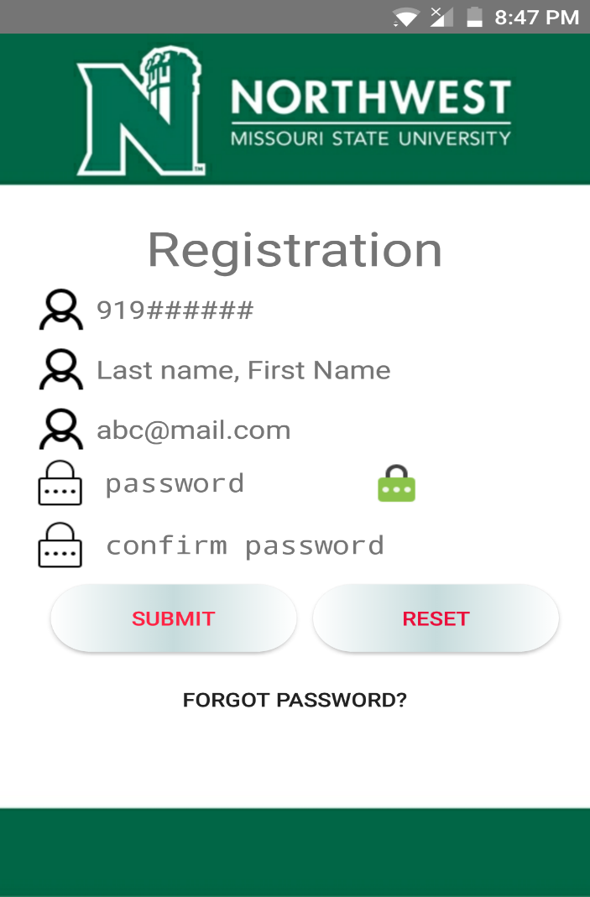

**Figure 2. Registration Page**

* 1. **System Menu**

Emergency Reporting System android application consists of 3 navigation menus. One is the Main Home page consisting of Emergency and File complaint icons. Second is the Complaints tab where users can register a complaint to UPD. Third lists contact numbers to be used when users need in particular situation.

* + 1. **Home Page**

Home page consists of 2 icons and one button where each one when clicked on them navigates to different page. Emergency button at the center must be used by the users to report any emergency like fire, health, harassment etc. to police. Immediately an email is sent to UPD with user location in it which helps UPD staff to take immediate measures. Below is a File Complaint Here icon, which when clicked navigates to register a complaint page where user can select complaint type and submit mail to UPD. Logout button on top is used to get to LogIn page. When User clicks emergency button for the first time app asks the users permission to access the location, immediately the user gets Message sent pop-up message on the Home page when the user location is sent to UPD.

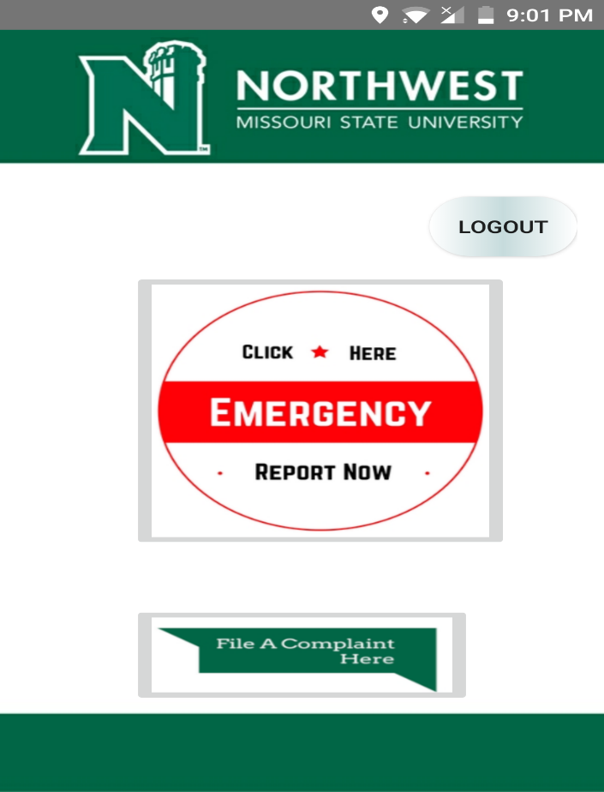

**Figure 3. Home Page**

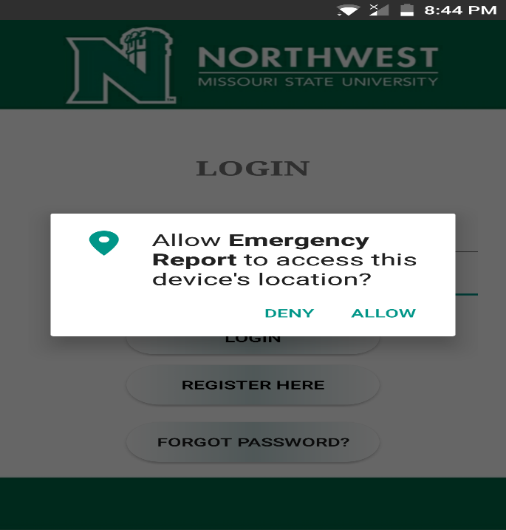

**Figure 4. Access Location**

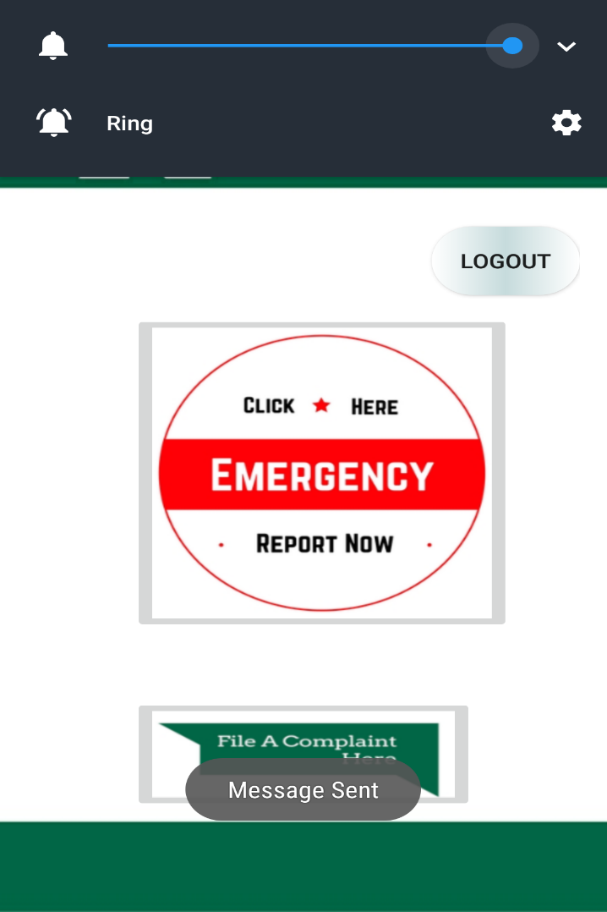

**Figure 5. Message Sent**

* + 1. **File A Complaint Page**

Through File a Complaint page users can report a complaint to the police department which is not emergency but the user like to register a complaint to UPD. Non-emergency situations can be like complaining about stolen things, car damage, complaining about a disturbance so on. Choose a Complaint Type is a drop down-menu when clicked helps users to select type of complaint he/she trying to inform to UPD. Write a complaint here! Is the place where users need to write description for the complaint that they are wishing to report to UPD to take actions. Finally by clicking on Submit button user’s task of reporting complaint is finished and mail is sent to UPD containing description of complaint. Bottom is Emergency Phone Numbers button which can be used to get contact numbers of UPD staff belonging to different departments like Fire, Health, and Counselling etc.

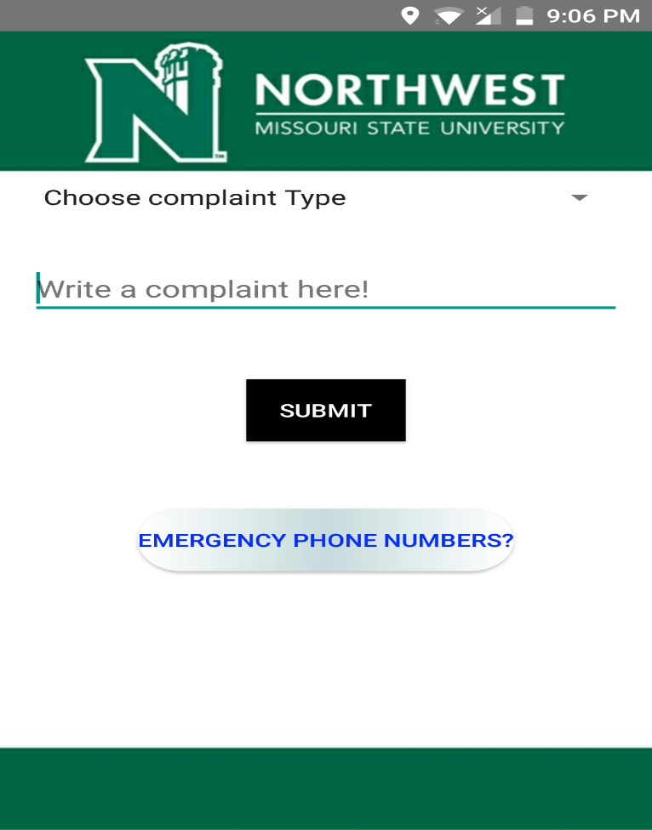

**Figure 6. File a Complaint Page**

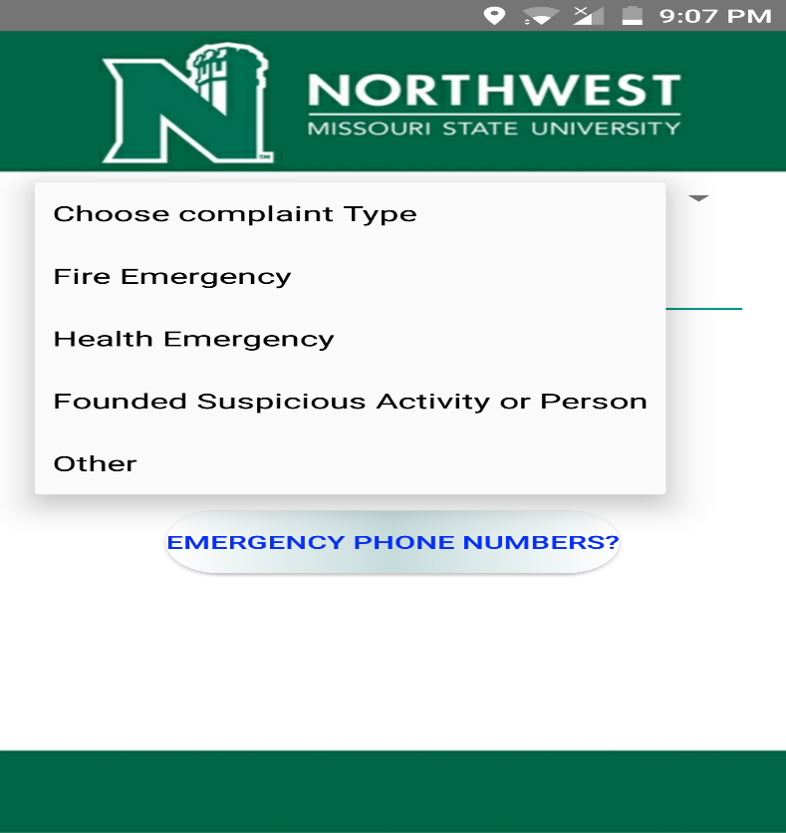

**Figure 7. Drop down-menu**

* + 1. **Emergency Phone Numbers**

Emergency phone number tab is a table view displaying all contact numbers of UPD departments which may be very helpful to the users in emergency situations. There are variety of departments in UPD specific for each situation like contacts for Alcohol and Drug Problems, Rape and Family Violence, Hospital Emergency/ Medical Care.

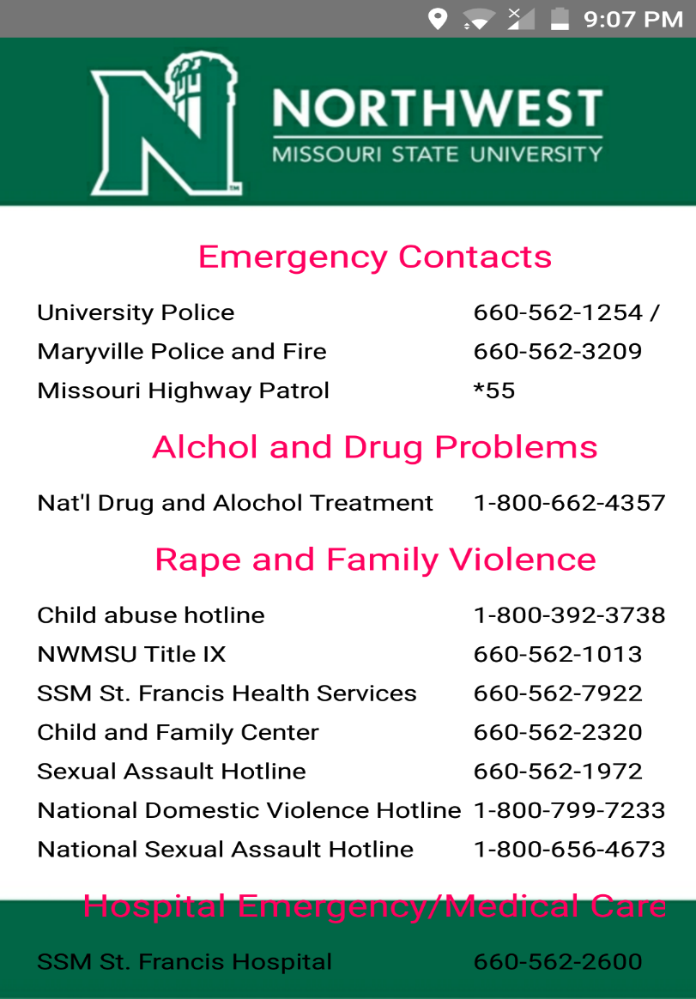

**Figure 8. Emergency Phone Numbers Page**

* 1. **Exit System**

User can exit from application just by closing the application. There is also logout button provided in the Home page of the application. But user need not logout from the application every time after the usage of the application.

**4.0 ADDITIONAL INFORMATION**

1. **ADDITIONAL INFORMATION**

Email sent to UPD consists of user location and details of the user.

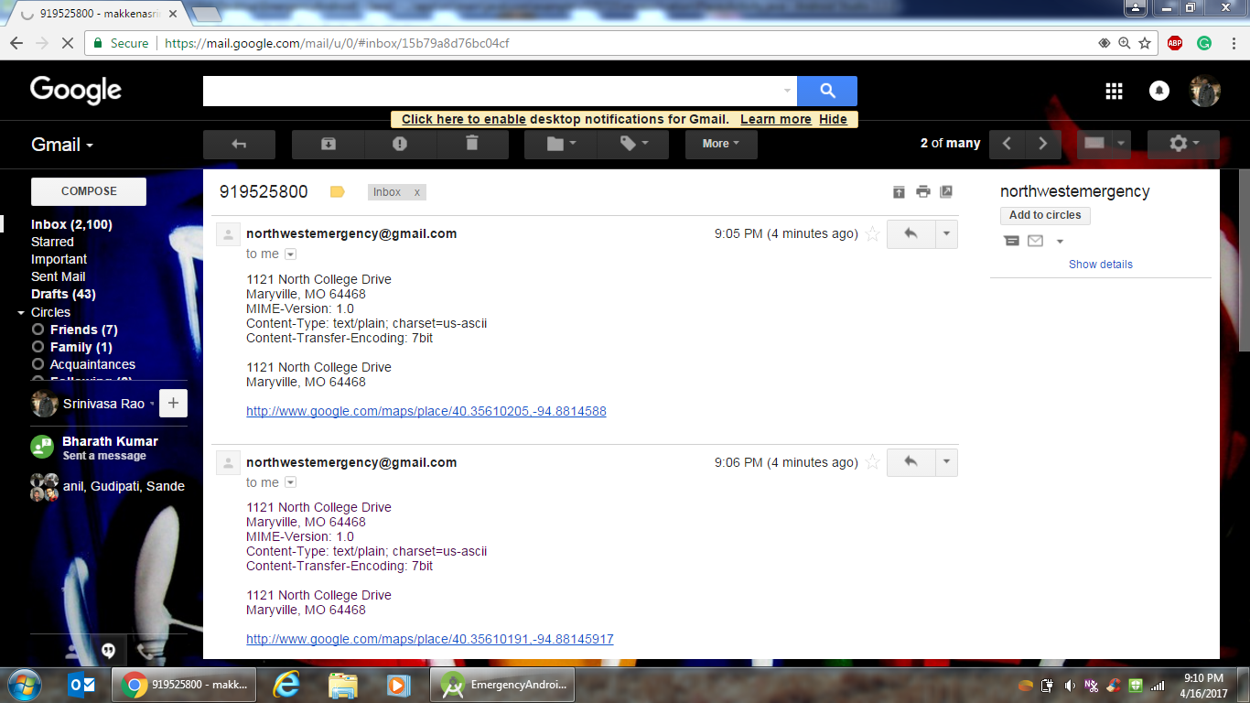**Figure 9. Mail sent to UPD**

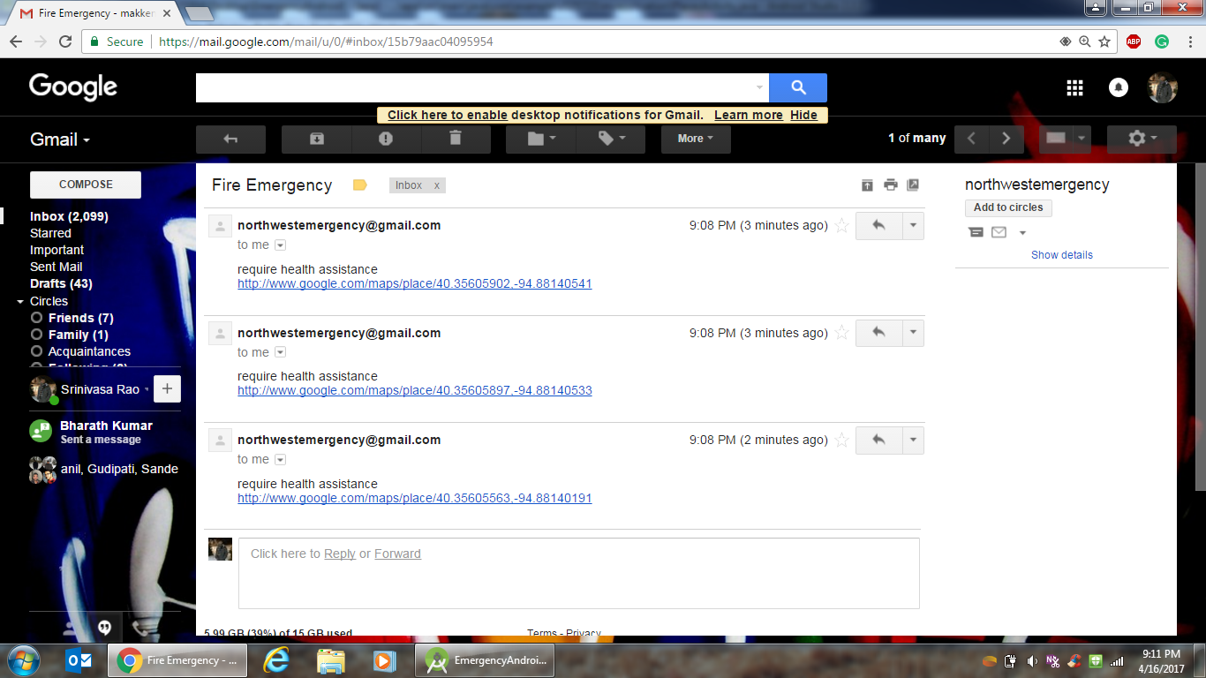**Figure 10. Mail sent to UPD with Complaint Type**

Database used for this app is back4app:

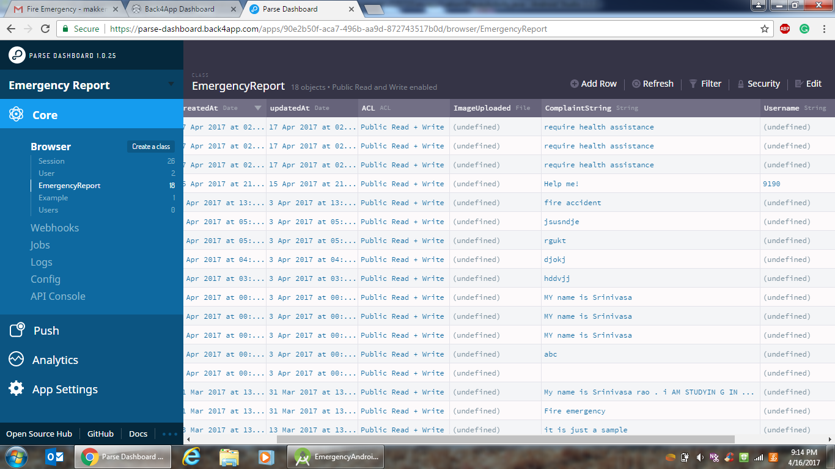**Figure 11. Back4app Database**